Assignment-01

Name: Ronit Rout Serial Number: 38
Registration Number: 24E118B08 Assignment Number: 01
Section: 24E1B1 Date: 30-09-2026

Question 1
import numpy as np
data = np.array([[10, -20, 30], [40, -50, 60], [70, 80, -90]])
row_means = np.mean(data, axis=1)
col_means = np.mean(data, axis=0)
row_std = np.std(data, axis=1)
max_col = np.max(data, axis=0)
min_row = np.min(data, axis=1)
print("Row means:", row_means)
print("Column means:", col_means)
print("Row standard deviations:", row_std)
print("Maximum values in each column:", max_col)
print("Minimum values in each row:", min_row)
Output
Row means: [ 6.66666667 16.66666667 20. ]
Column means: [40. 3.33333333 0. ]
Row standard deviations: [20.54804668 47.84233365 77.88880964]
Maximum values in each column: [70 80 60]
Minimum values in each row: [-20 -50 -90]

Question 2:
A = np.array([ [2, -4], [-6, 8]])
B = np.array([ [1, -3], [-5, -7]])

print("A+B:")
print(A + B)
print("A-B:")
print(A - B)
print("A.B:")
print(A @ B)
print("Transpose of A:")
print(A.T)
print("Determinant of A:")
print(np.linalg.det(A))
print("Inverse of A:")
print(np.linalg.inv(A))
output:
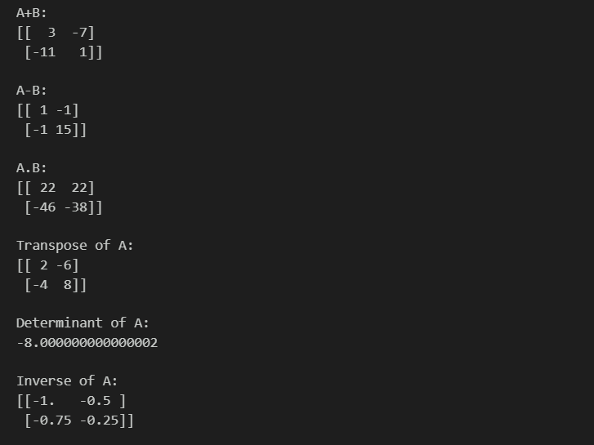
Question 3:
Code:
import numpy as np
import matplotlib.pyplot as plt
import random
import pandas as pd
from scipy import stats
import pandas as pd
data={
'product':['laptop','Smartphone','Monitor','Headphone','Mouse'],
'Price':[200000,180000,15000,32000,5000],
'Sales':[150000,120000,10000,12000,1000],
'profit':[50000,20000,5000,5000,2000]
}
df=pd.DataFrame(data)
print("Dataframe:\n",df)
print("\nColumn Name:",df.columns)
print("\nNumber Of Rows & columns :",df.shape)
print("\nFirst 3 Rows:\n",df.head(3))
print("\nOnly Sales And Profit Column:\n",df[['Sales','profit']])
print("\nAverage Sales:", df['Sales'].mean())
print("Maximum Sales:", df['Sales'].max())
print("Minimum Sales:", df['Sales'].min())
print("\nProducts with Profit > 4000:\n",df[df['profit'] > 4000]['product'])
df.sort_values('profit',ascending=False)
print("\nDataframe sorted by Profit (Descending):\n",df)

output:
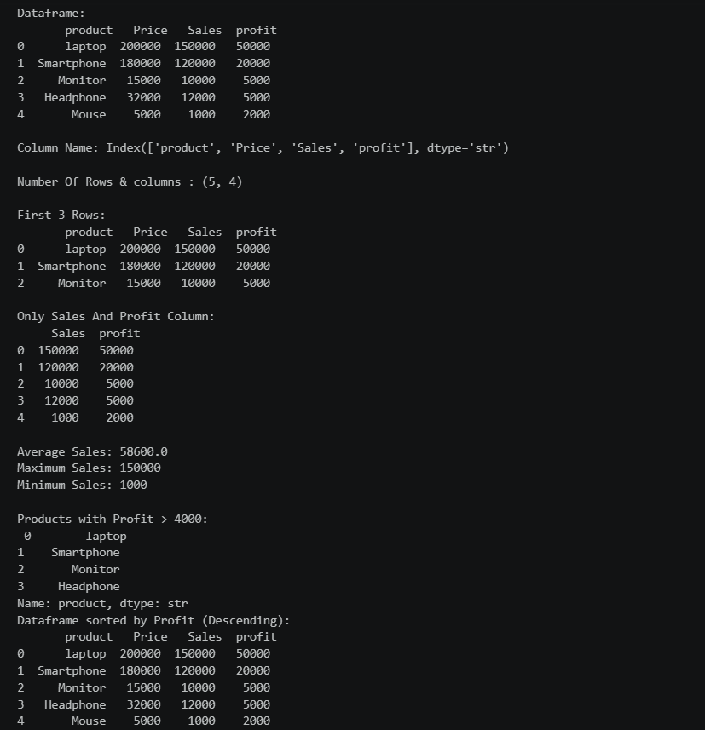
Question 4:
plt.figure(figsize=(8, 5))
plt.scatter(df['Price'], df['Sales'], marker='o', label='Products')
High_ind = df['Sales'].idxmax()
plt.scatter(
df.loc[High_ind,'Price'],
df.loc[High_ind,'Sales'],
marker='o',
color='red',
s=150,
label='Highest Sales'
)
output:
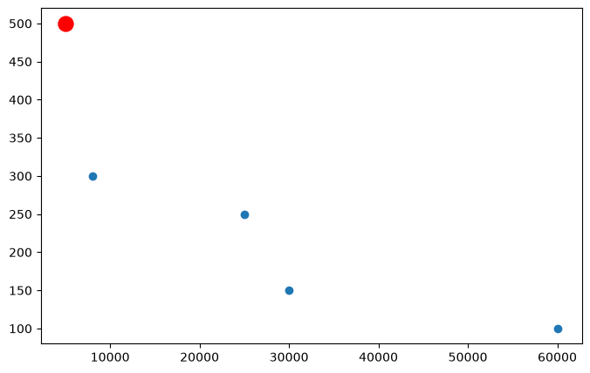
plt.figure(figsize=(8, 5))
plt.plot(
df['Products'],
df['Sales'],
marker='o',
linestyle='-',
label='Sales'
)
plt.plot(
df['Products'],
df['Profit'],
marker='s',
linestyle='--',
label='Profit'
)
output:
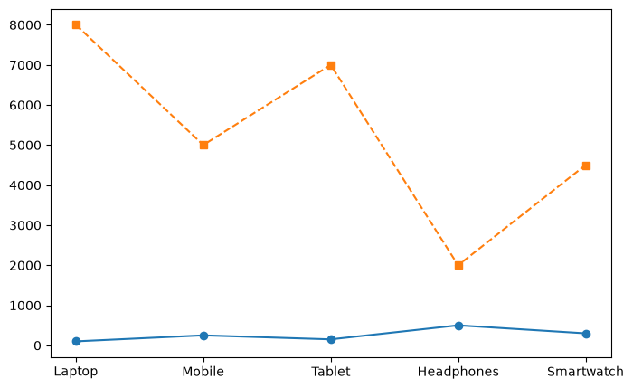

plt.figure(figsize=(8, 5))
bars = plt.bar(df['Products'], df['Profit'])
plt.bar_label(bars, padding=3)
plt.xlabel('Products')
plt.ylabel('Profit')
plt.title('Profit by Product')
plt.show()
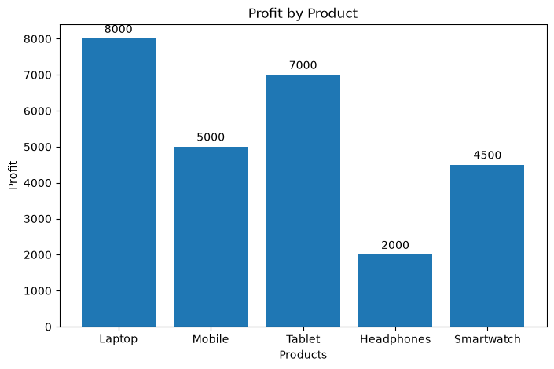
profit_margin = df['Profit'] / df['Sales'] * 100
plt.figure(figsize=(8, 5))
bars = plt.bar(df['Products'], profit_margin)
plt.bar_label(bars, padding=1)
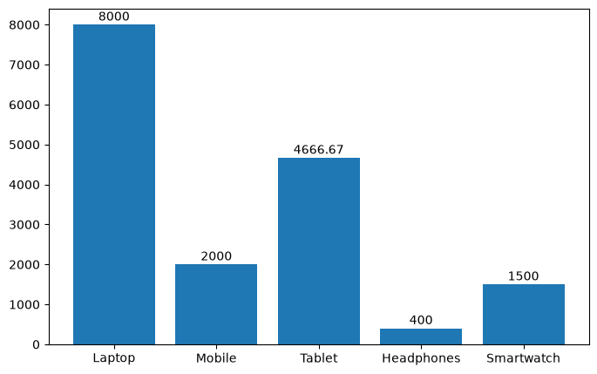

plt.figure(figsize=(7, 7))
plt.pie(
df['Sales'],
labels=df['Products'],
autopct='%1.1f%%'
)
plt.title('Percentage Contribution of Each Product to Total Sales')

plt.figure(figsize=(8, 5))
plt.hist(df['Sales'], bins=5, edgecolor='black')
plt.xlabel('Sales')
plt.ylabel('Frequency')
plt.title('Distribution of Sales')
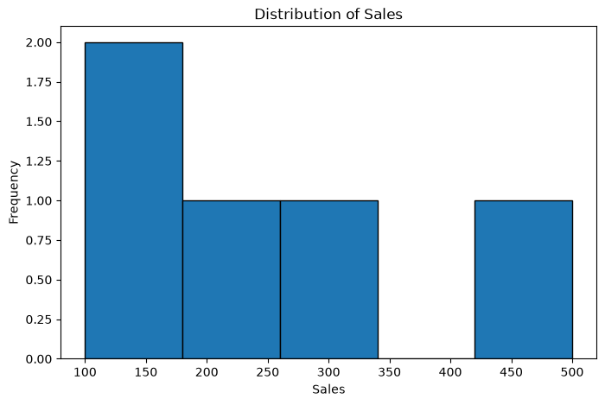
Question 5:
Question 5:
ns = 100 # number of samples
sd = np.random.randint(1, 101, ns)
ts = 4 * sd + np.random.normal(0, 20, ns)
df = pd.DataFrame({
"StudyHour": sd,
"TestScore": ts
})
print("Complete Dataset:")
print(df)
output:
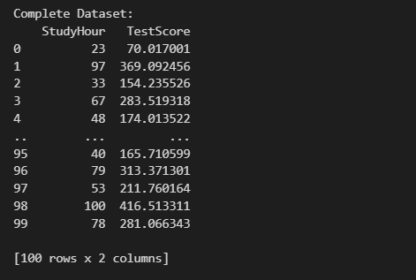
print("\nNumber of samples:", df.shape[0])
print("Number of features:", 1)
print("Number of target variables:", 1)
print("Feature name:", "StudyHour")
print("Target name:", "TestScore")
print("Shape of dataset:", df.shape)
print("Data type of feature:", df["StudyHour"].dtype)
Output:
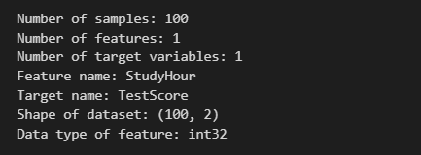
print("\nStatistics:")
print(df.describe())
print("\nMissing Values:")
print(df.isnull().sum())

output:
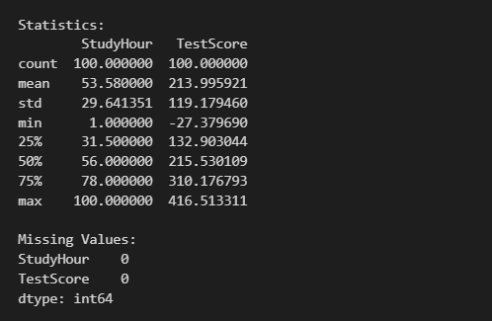
plt.scatter(df["StudyHour"], df["TestScore"])

plt.title("Study Hours vs Test Score")
plt.xlabel("Study Hours")
plt.ylabel("Test Score")
output:
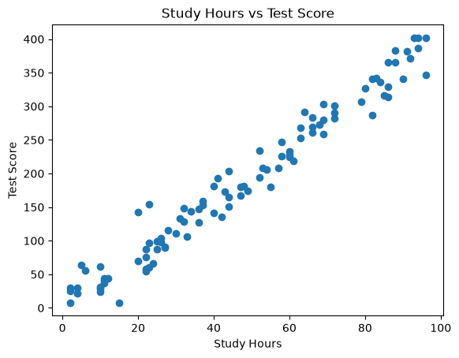
Question 6:
import numpy as np
import matplotlib.pyplot as plt
import random
import pandas as pd
from scipy import stats
ns = 100 # number of samples
sd = np.random.randint(1, 101, ns)
ts = 4 * sd + np.random.normal(0, 1, ns)
df = pd.DataFrame({
"StudyHour": sd,
"TestScore": ts
})
print("Complete Dataset:")
print(df)
Output:
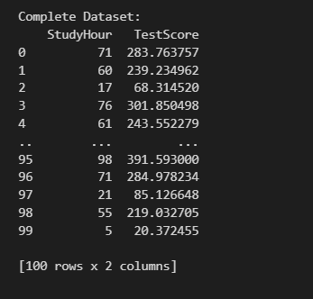
x=df.StudyHour
y=df.TestScore

from sklearn.model_selection import train_test_split
xtrain,xtest,ytrain,ytest=train_test_split(x,y,test_size=20,random_state=42)
print("Number of training samples:", len(xtrain))
print("Number of testing samples:", len(xtest))

Output:

#model creationlinear regression predictions.csv
from sklearn import linear_model
lr = linear_model.LinearRegression()
xtrain=xtrain.values.reshape(80,1)
xtest=xtest.values.reshape(20,1)
#training
lr.fit(xtrain, ytrain)
cf = lr.coef_[0].round(2)
intc = lr.intercept_.round(2)
print("\nSlope (Coefficient):", cf)
print("Intercept:", intc)
#Equation of the line
equ=f"TestScore={cf}*StudyHour+{intc}"
print("\nRegression Equation:", equ)
Output:
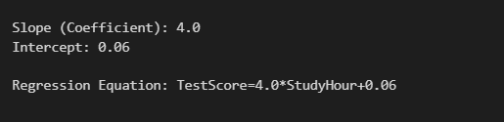
#model testing
ypred=lr.predict(xtest)
print(ypred)
print(ytest)
output:
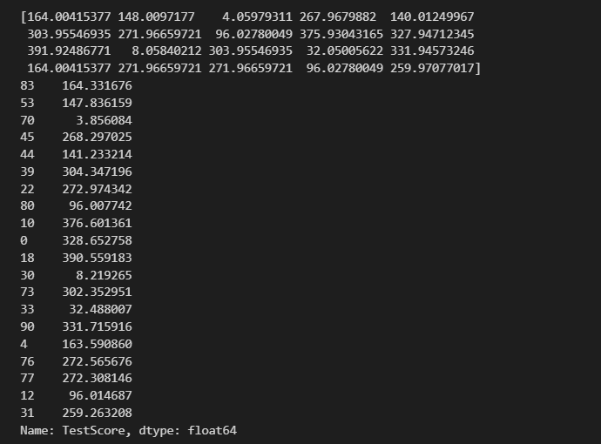
from sklearn import metrics
RSS=np.sum((ytest-ypred)**2).round(2)
print("RSS:",RSS)
MAE=metrics.mean_absolute_error(ytest,ypred)
print("MAE:",MAE)
MSE=metrics.mean_squared_error(ytest,ypred)
print("MSE:",MSE)
RMSE=np.sqrt(MSE)
print("RMSE:",RMSE)
TSS=np.sum((ytest-np.mean(ytest))**2).round(2)
print("TSS:",TSS)
R2=(1-(RSS/TSS)).round(2)
print("R2 value:",R2)
output:
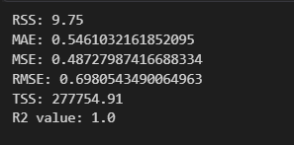
df2 = pd.DataFrame({
"StudyHour": xtest[:, 0],
"Y-Actual": ytest.round(2),
"Y-Predict": ypred.round(2)
})
df2 = df2.reset_index(drop=True)
print("\nActual vs Predicted:")
print(df2)
Output:
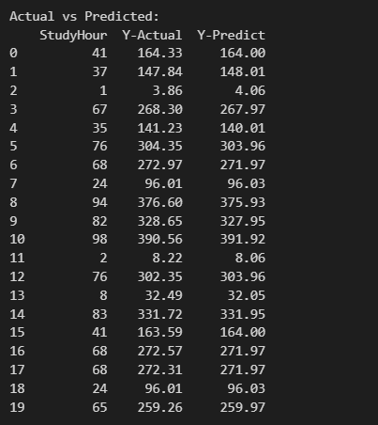
# Save results to CSV
df2.to_csv("linear_regression_predictions.csv", index=False)
print("\nResults saved successfully.")

output:

plt.scatter(xtest, ytest, label="Actual")
plt.plot(xtest, ypred, label="Regression Line")
plt.xlabel("Study Hour")
plt.ylabel("Test Score")
plt.title("Linear Regression")
plt.legend()
plt.grid(True)
plt.show()
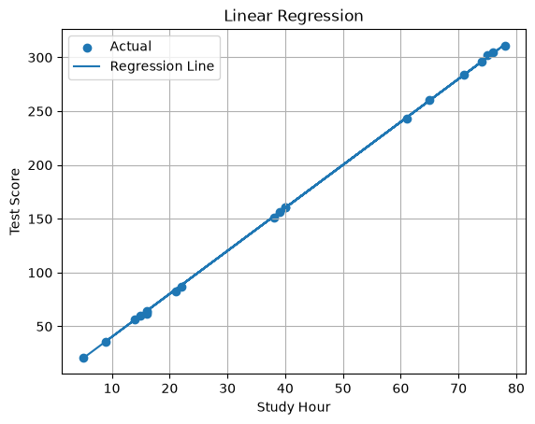
HOME-ASSIGNEMENT-01
Q1:
MARKS = np.array([ [80, 75, 90], [65, 70, 72], [90,88, 95], [55, 60, 58]])
print("Average of each student marks: ", np.mean(MARKS, axis=1))
print("Highest student Average marks: ", np.max(np.mean(MARKS, axis=1)))
print("Average of each subject marks: ", np.mean(MARKS, axis=0))
print("Highest subject Average marks: ", np.max(np.mean(MARKS, axis=0)))
print("student averages MORE THAN 75:",np.where(np.mean(MARKS, axis=1) > 75)[0])
Output:
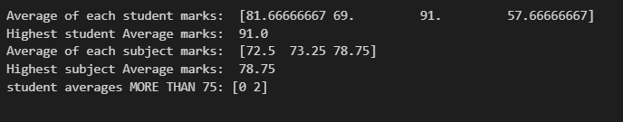
Q2:
data={
'product':['laptop','Smartphone','Monitor','Headphone','Mouse'],
'Price':[200000,180000,15000,32000,5000],
'Sales':[150000,120000,10000,12000,1000],
'profit':[50000,20000,5000,5000,2000]
}
df=pd.DataFrame(data)
plt.scatter(df['Price'],df['Sales'],c=df['profit'],s=df['profit'] / 100, cmap='viridis')
for i in range(len(df)):
plt.annotate(df['product'][i], (df['Price'][i], df['Sales'][i]), xytext=(8,8), textcoords='offset points')
Output:
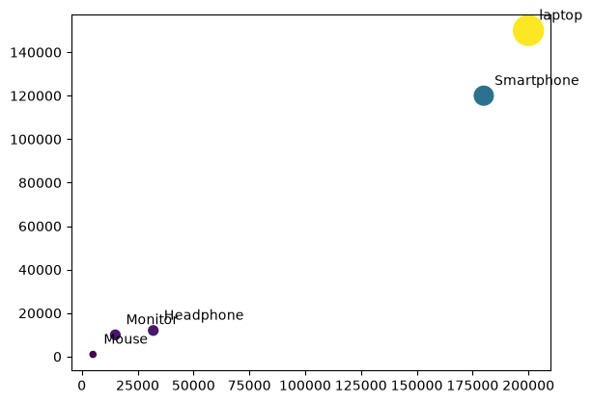
Question 3:
import pandas as pd

df=pd.read_csv("Breast_Cancer_data.csv",header=None)

df
Output:
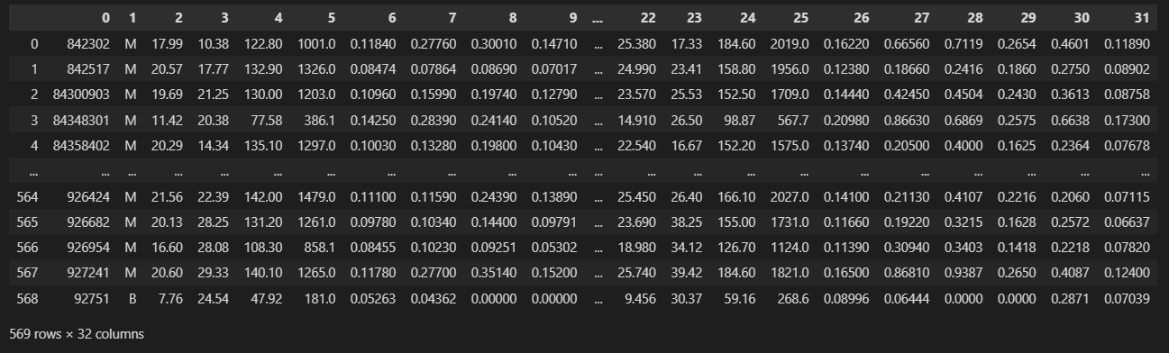
Question 4:
A company has a dataset containing 20000 customer records. Each record has:
• Age
• Income
• Number of purchases
• Membership duration
• Website visits
• Customer spending {Target Var.}
1. Total number of samples:
$N=20000$
2. Number of input variables:
$p=5$
3. Input vector for the i-th sample:
$x_{i}={\left({Age}_{i}, {Income}_{i}, {Purchases}_{i}, {Membership}_{i}, {Visits}_{i}\right)}^{T}∈R^{5}$
4. Output variable:
$y_{i}={CustomerSpending}_{i}$
5. Input matrix X and its dimensions:
$X=\left[x_{1}^{T} x_{2}^{T} ⋮ x_{20000}^{T} \right]$
$X∈R^{20000×5}$
6. Output vector y and its dimensions:
$y=\left[y_{1} y_{2} ⋮ y_{20000} \right]$
$y∈R^{20000×1}$
7. Complete dataset:
$D=\left\{\left(x_{i}, y_{i}\right)\right\} for i=1, 2, …, 20000$
8. Machine learning function:
$f:R^{5}→R$
$y=f\left(x\right)$
9. Prediction equation:
${\hat{y}}_{i}=f\left(x_{i}\right)$
10. Training dataset:
Since 16000 samples are used for training:
$D_{train}=\left\{\left(x_{i}, y_{i}\right)\right\} for i=1, 2, …, 16000$
$X_{train}∈R^{16000×5}$
$y_{train}∈R^{16000×1}$
11. Testing dataset:
Number of testing samples:
$20000−16000=4000$
$D_{test}=\left\{\left(x_{i}, y_{i}\right)\right\} for i=16001, 16002, …, 20000$
12. Dimensions of X_test:
$X_{test}∈R^{4000×5}$
Question5:
import numpy as np
import matplotlib.pyplot as plt
import random
import pandas as pd
from scipy import stats
df=pd.read_csv("Simple_House_Price.csv")
dependent_variable = df['Price']
independent_variable = df['Area_sqft']
x=independent_variable
y=dependent_variable
plt.scatter(x,y)
plt.xlabel("Area_sqft")
plt.ylabel("Price")
plt.title("Scatter plot of Area_sqft vs Price")
Output:
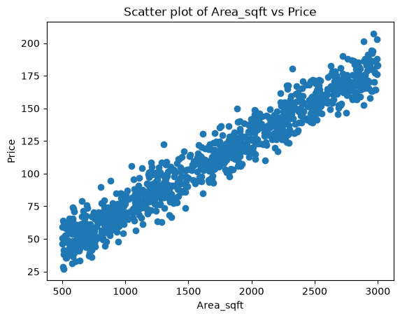
xtrain,xtest,ytrain,ytest=train_test_split(x,y,test_size=.2,random_state=42)
x_train = xtrain.values.reshape(-1, 1)
x_test = xtest.values.reshape(-1, 1)
print("Training samples:", len(x_train))
print("Testing samples:", len(x_test))

print("Training percentage:", (len(x_train) / len(df)) * 100, "%")
print("Testing percentage:", (len(x_test) / len(df)) * 100, "%")
Output:
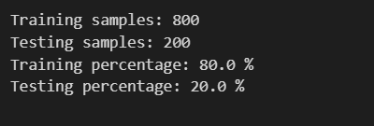

#train and testing
lr=LinearRegression()
lr.fit(xtrain,ytrain)
ypred=lr.predict(xtest)
print("Predicted values:", ypred)
print("Dimensions of target variable:", ytest.shape)
print("Dimension of predicted variable:", ypred.shape)
Output:
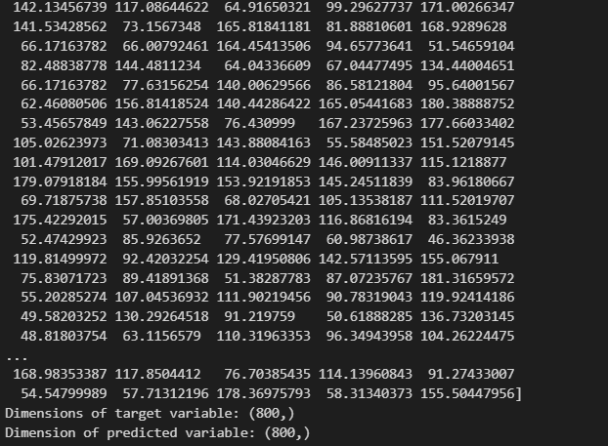
y_test_pred = lr.predict(xtest)
result = pd.DataFrame({
"Area_sqft": xtest.flatten(),
"Actual Price": ytest.values,
"Predicted Price": y_test_pred
})
result["Residual"] = result["Actual Price"] - result["Predicted Price"]

print("\nTesting Results:")
print(result)
Output:
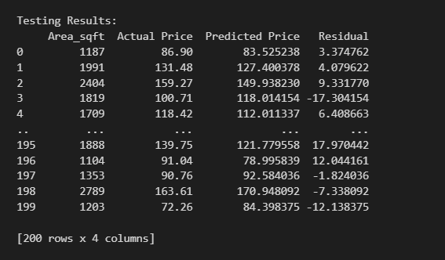
mae = mean_absolute_error(ytest, y_test_pred)
rmse = np.sqrt(mean_squared_error(ytest, y_test_pred))
r2 = r2_score(ytest, y_test_pred)

print("\nModel Evaluation:")
print("MAE:", mae)
print("RMSE:", rmse)
print("R2 Score:", r2)
if rmse > mae:
print("\nRMSE is larger than MAE.")
print("RMSE:", rmse)
print("MAE:", mae)
else:
print("\nMAE is larger than RMSE.")
print("MAE:", mae)
print("RMSE:", rmse)

Output:
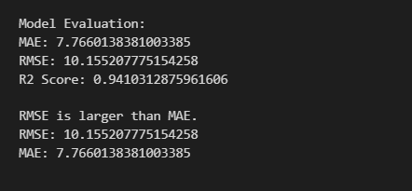
—-------X—----------

